2020 Sorghum Festival
October 2-4, 2020
Date _____Booth# ______
Check # _____Cash ______
___Booth(s) 10x10 ______
Electric Y/N ______
Total ______

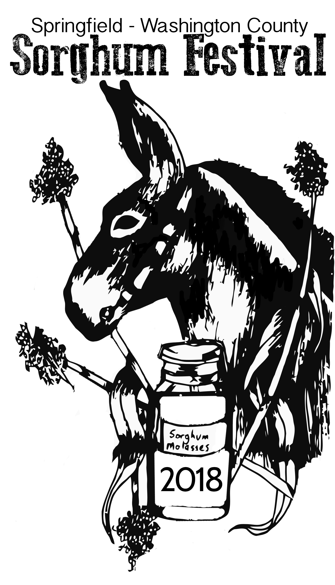

Name ____________________________________________________ Phone ______________________________
Address __________________________________________________________________________________________
City ____________________________________________________ State__________ Zip________________
Email __________________________________________________________________________________________
Item to be sold: (Please submit photos) __________________________________________________________________________________________________________________________________________________________________________________________________
Choose from the following for Arts & Crafts, Civic, School/Church Organizations:
Early Bird Special $50.00 through August 31st. After August 31st $70.00
10x10 booth(s) ___________ Electricity: Yes___ No ___ ($25) *20 amps only,
Carnival/Inflatable Businesses 10% of gross proceeds ______ (due at the close of the festival).
SET UP: Friday (10/2) 6:00 – 8:00 PM *Set up must take place at this time
VENDING HOURS: Saturday (10/3) 9:00 AM – Close
Sunday (10/4) To be determined
Rules and Regulations:
1. Vendor agrees to sell only those items listed on booth application/agreement. The Sorghum Festival Committee
reserves the right to eliminate the selling of items not approved by the Committee.
2. Vendor must provide the following: chairs, tables, shelter, heavy duty electric cords, weights for tents. (absolutely no
drilling is allowed into pavement)
3. Absolutely no vehicles may be parked at booth sites on Cross Main Street or other areas used for Vendors.
4. The selling of other items bearing the name or logo of the Sorghum Festival is restricted unless prior written
permission has been granted by the Sorghum Festival Committee.
5. Vendors selling food must first be approved by the Sorghum Festival Committee/must provide Health Department
certificate.
6. Booth size not to exceed 10x10 ft. area. Tents larger than 10 x10 ft. may not be used. * No portable heaters allowed
7. Absolutely no drilling into street/pavement – NO exceptions.
8. No refunds will be processed unless request is submitted in writing by September 1, _____. Refunds will be reimbursed at 50% of
collected Vendor fee.
9. Friday night set up is for Tents, tables, and large items.
I hereby affirm that I have read and understand the above rules and regulations and consent to abide by the rules and regulations established by the Chamber of Commerce and the Sorghum Festival Committee for the 2019 year. I further agree that if myself or my organization does not meet these requirements or abide by these rules and regulations, I/we will be asked to leave without refund of rental fee.
Signature ________________________________________________________________ Date _______________________________
Springfield Washington County Chamber of Commerce
124 West Main Street, Springfield, KY 40069
859-336-5412 Ext 5
Email: administrator@springfieldkychamber.com

